**DS nano: Deep Learning**

**Lesson1_Introduction to Neural Networks**

**Perceptron Algorithm**

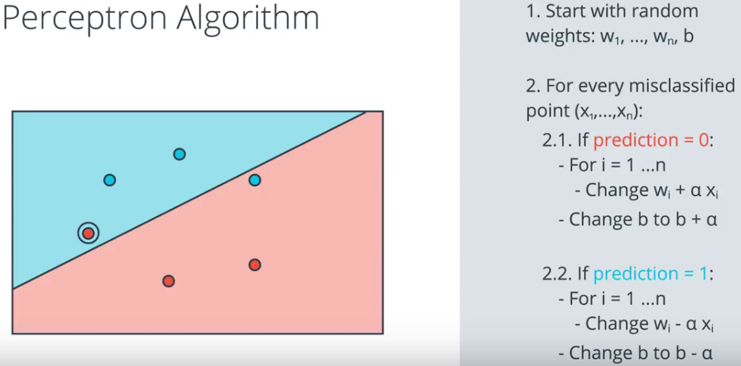

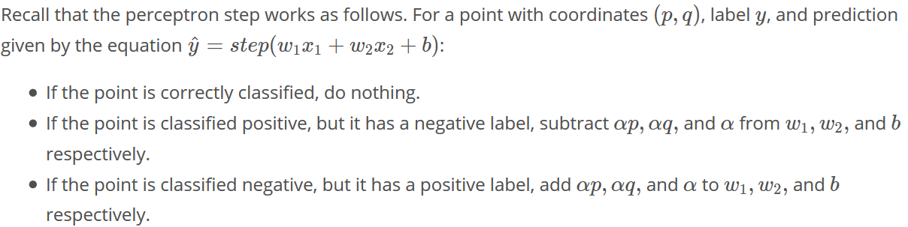

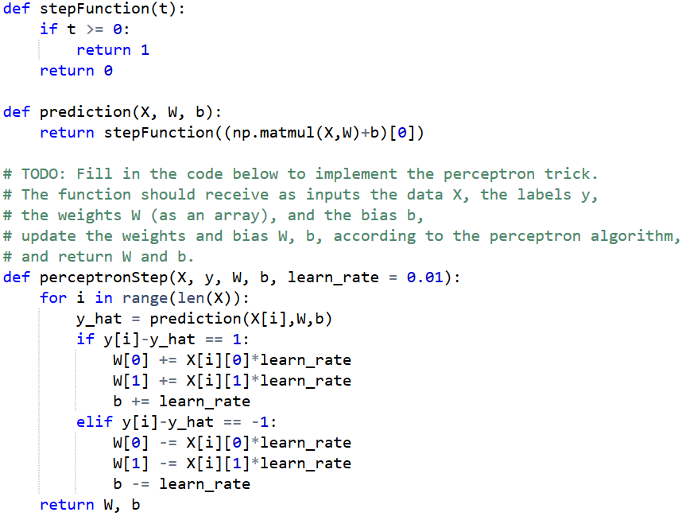

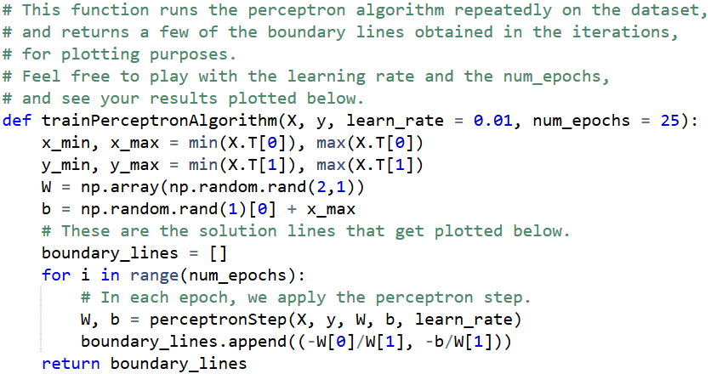

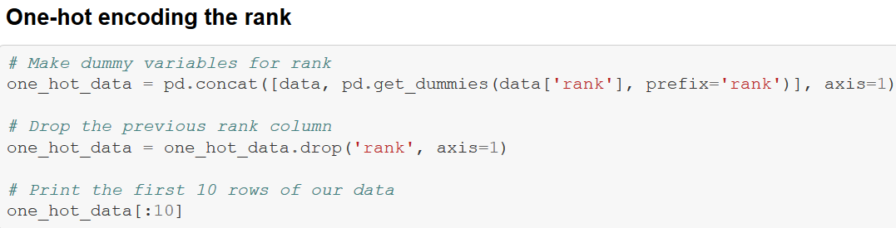

**Softmax:**

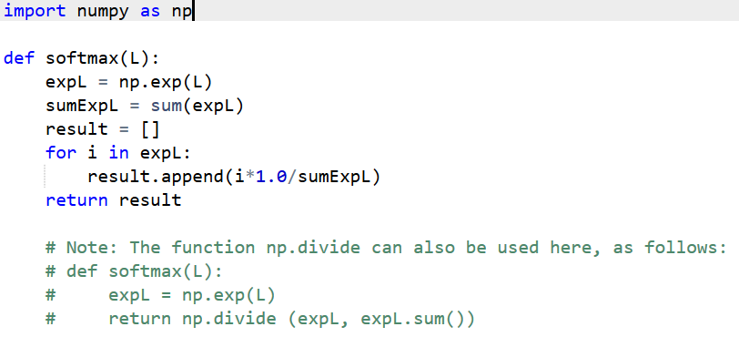

**Cross Entropy**

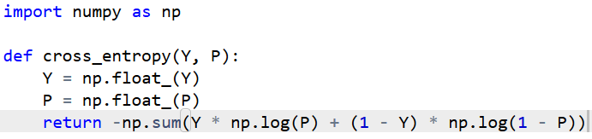

**Build the gradient descent algorithm:**

* **sigmoid: The sigmoid activation function.**
* **output_formula: The formula for the prediction.**
* **error_formula: The formula for the error at a point.**
* **update_weights: The function that updates the parameters with one gradient descent step.**

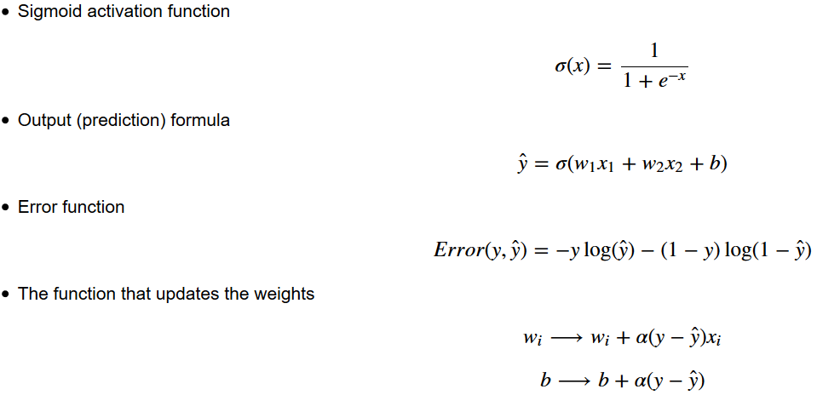

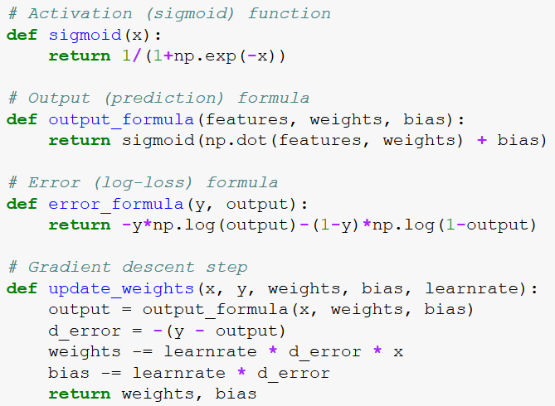

**Project: Student Admission (**[**https://github.com/udacity/deep-learning/blob/master/student-admissions/StudentAdmissions.ipynb**](https://github.com/udacity/deep-learning/blob/master/student-admissions/StudentAdmissions.ipynb)**)**

**DS nano: Deep Learning**

**Lesson2_Implementing Gradient Descent**

**Log-Loss Function & Mean Squared Error**

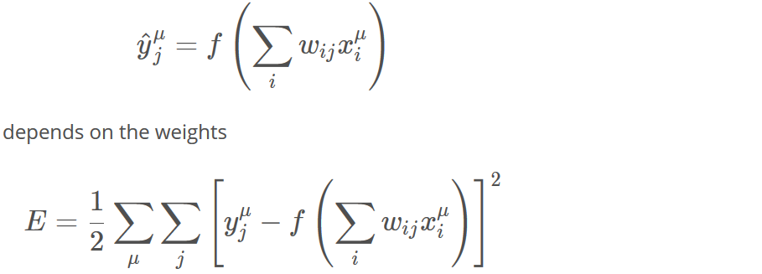

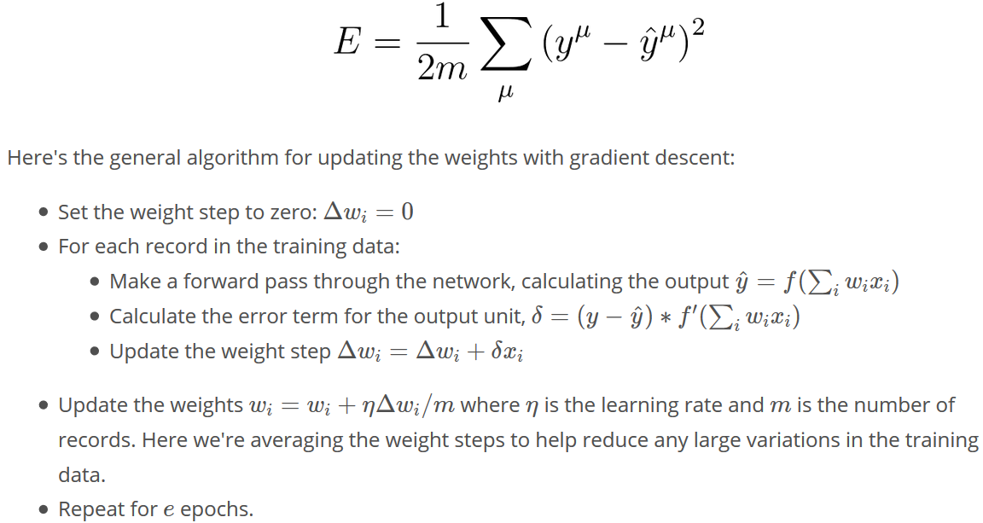

**Gradient Descent**

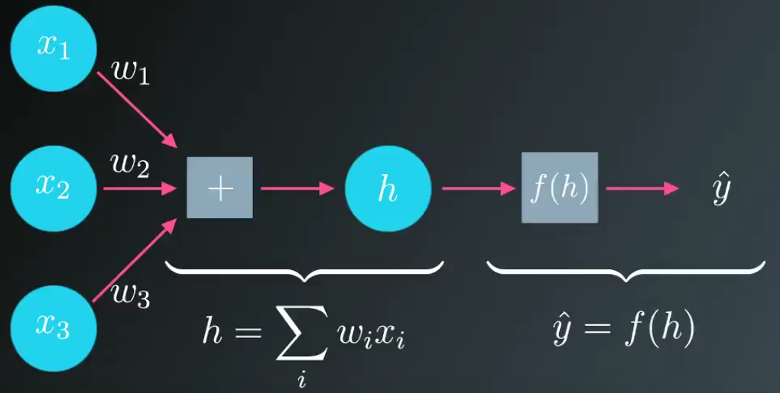

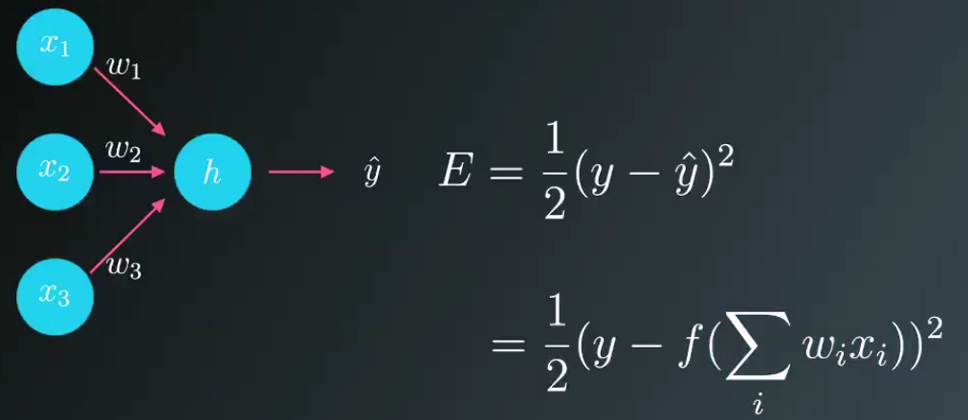

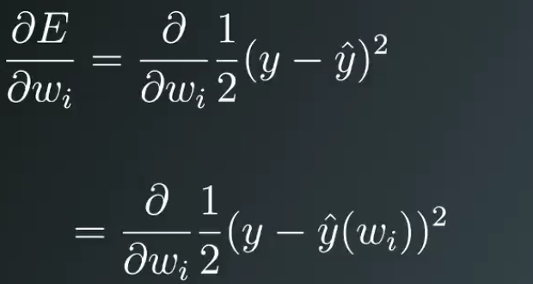

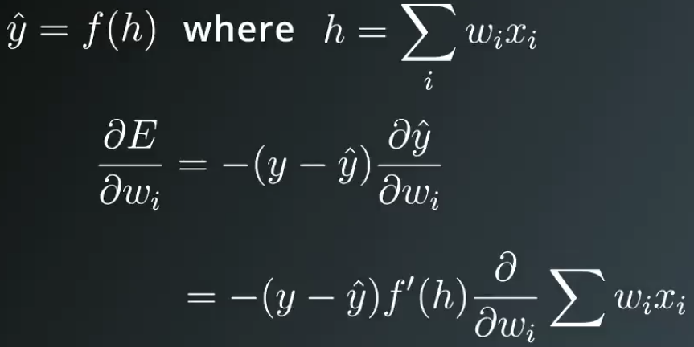

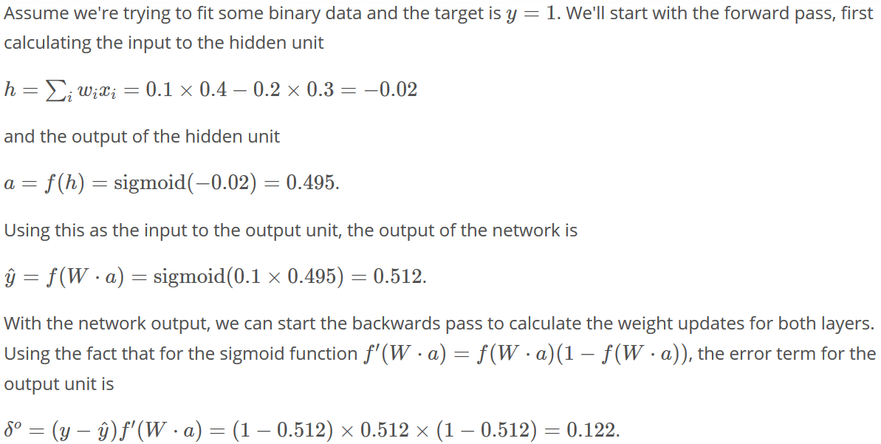

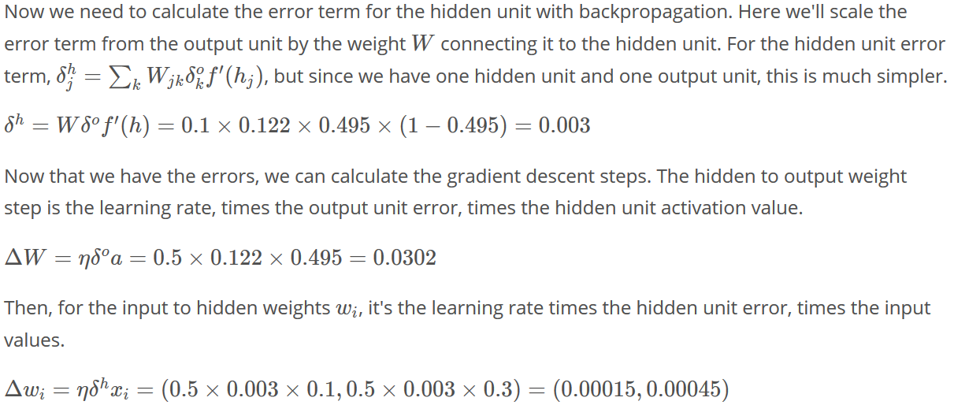

**Resource:**

[**https://medium.com/@karpathy/yes-you-should-understand-backprop-e2f06eab496b**](https://medium.com/@karpathy/yes-you-should-understand-backprop-e2f06eab496b)

**<https://www.youtube.com/watch?v=59Hbtz7XgjM>**

**DS nano: Deep Learning**

**Lesson3_Training Neural Networks**

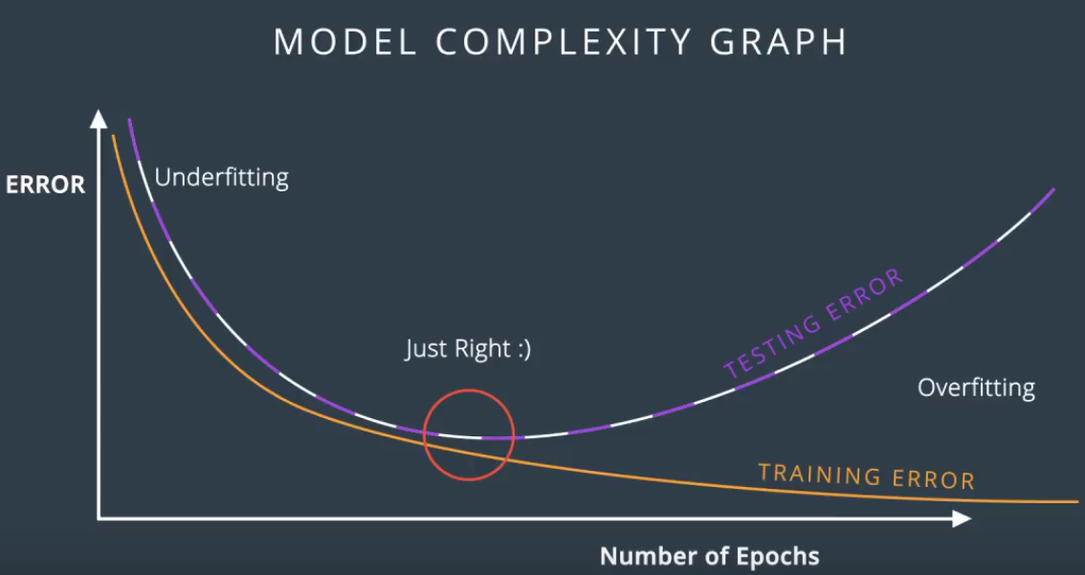

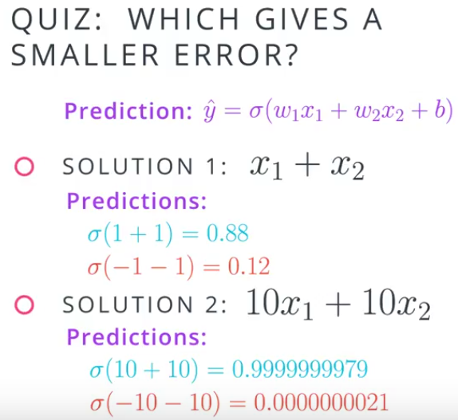

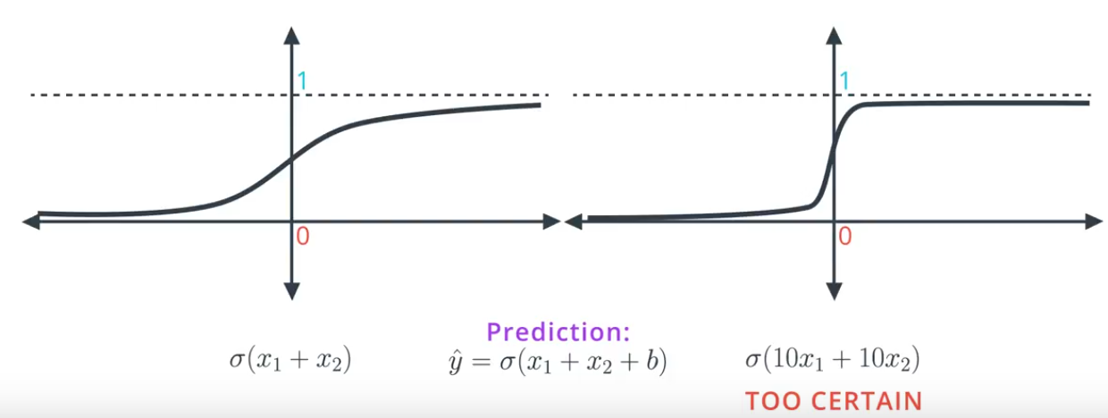  
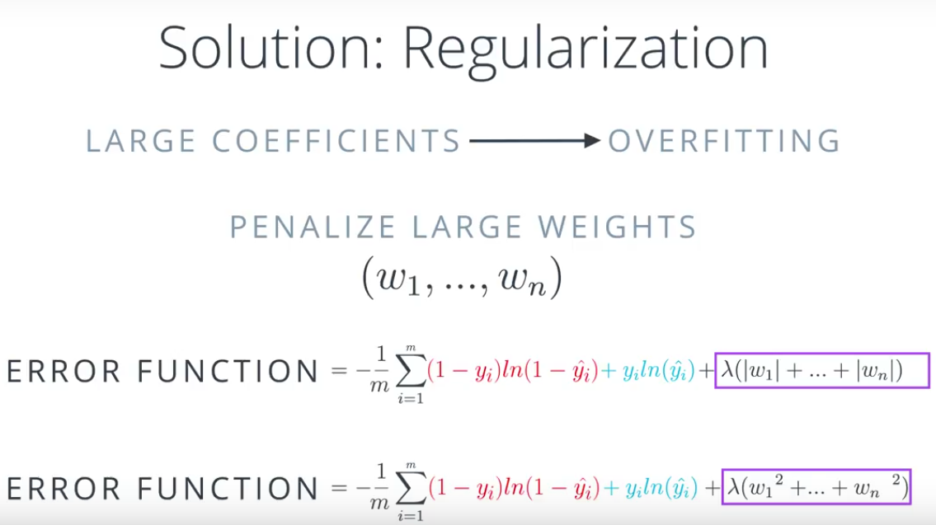

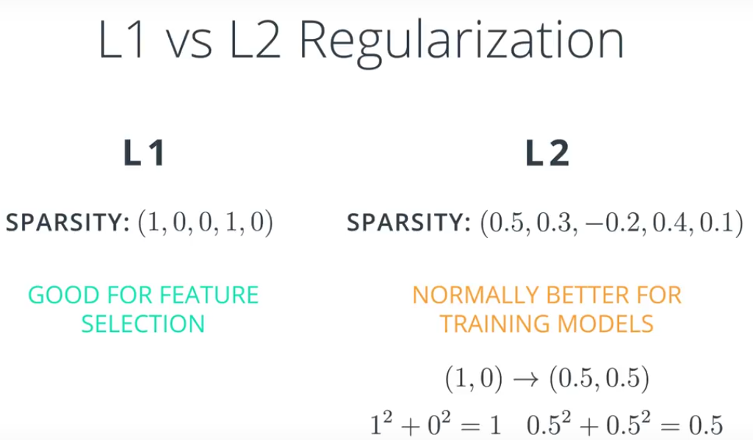

LOCAL MINIA:

* Random start
* Momentum

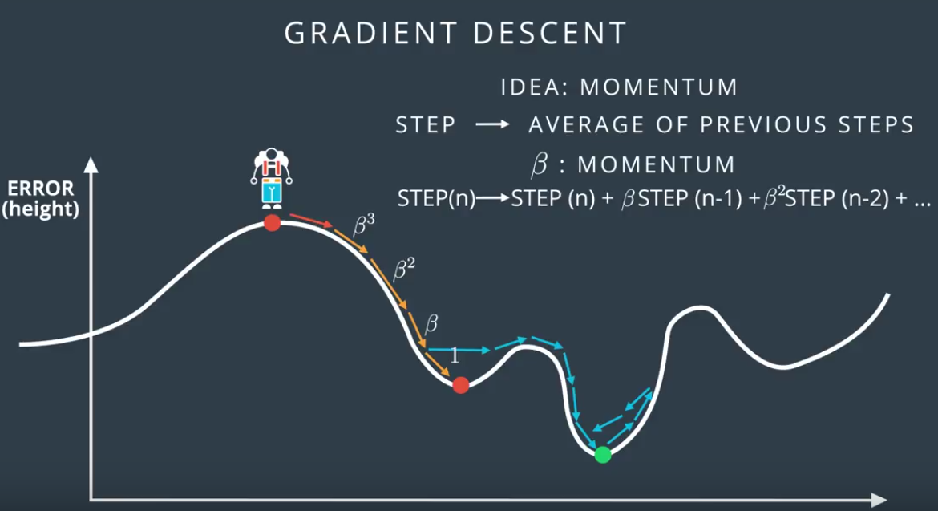

Get larger derivatives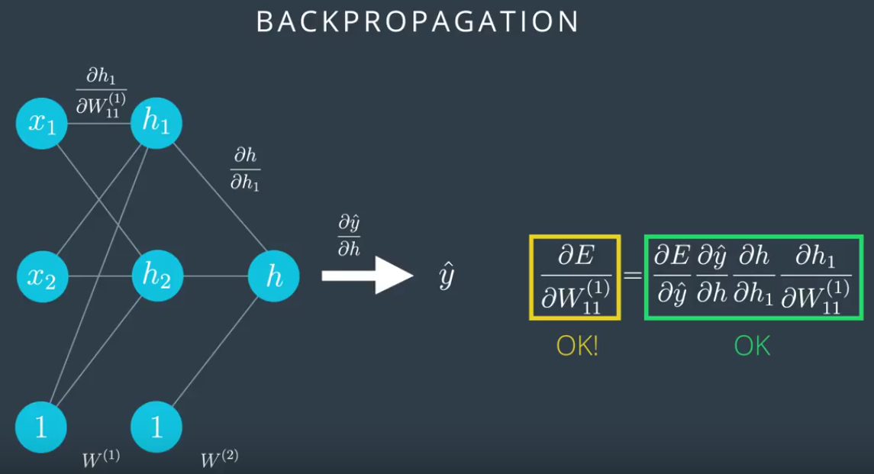

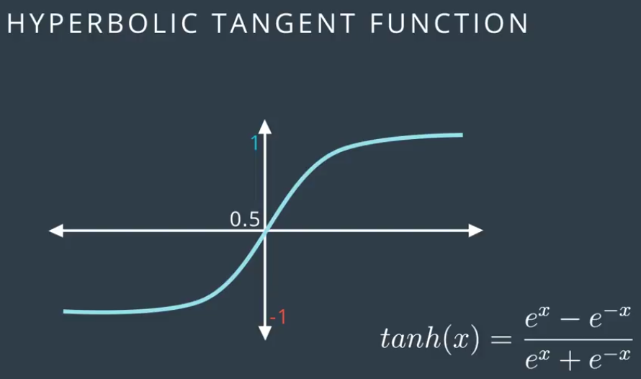

Hyperbolic tangent fxn: derivatives are larger

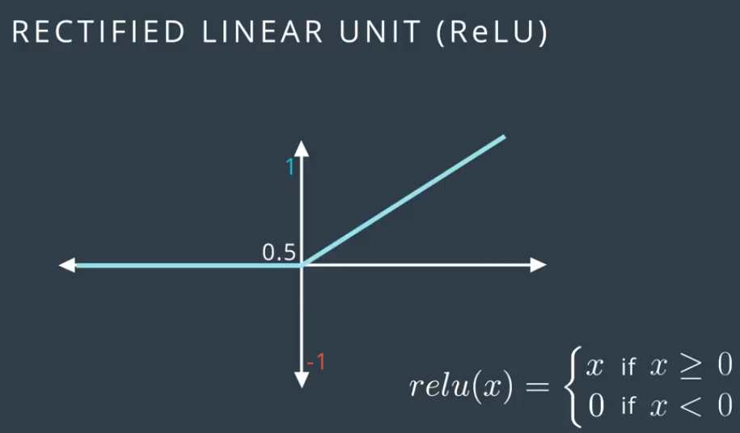

**DS nano: Deep Learning**

**Lesson4_Keras**

**Python Code:**

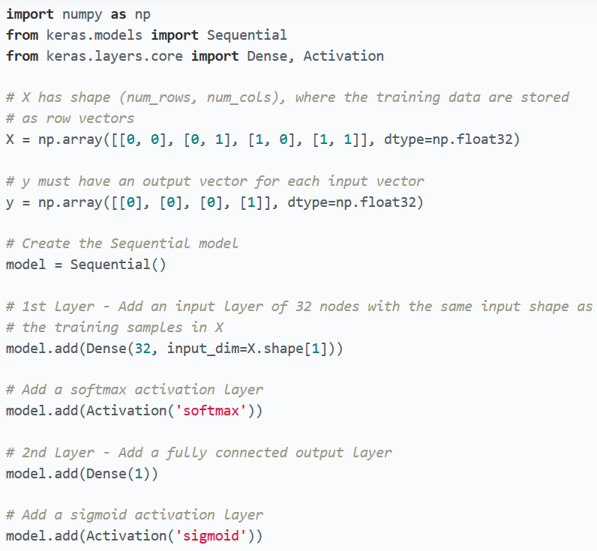

**Keras Optimization**

**https://keras.io/optimizers/**

**http://ruder.io/optimizing-gradient-descent/index.html#rmsprop**

**PyTorch**

**Part 1**

Converting between Numpy arrays and Torch tensors is super simple and useful. To create a tensor from a Numpy array, use torch.from_numpy(). To convert a tensor to a Numpy array, use the .numpy() method.

**Part 2**

**L8 Save the model: import fc_model**

**Save the weights and bias in the state: print(model.state_dict().keys())**

**Torch.save**

**Define the Network [Code]**

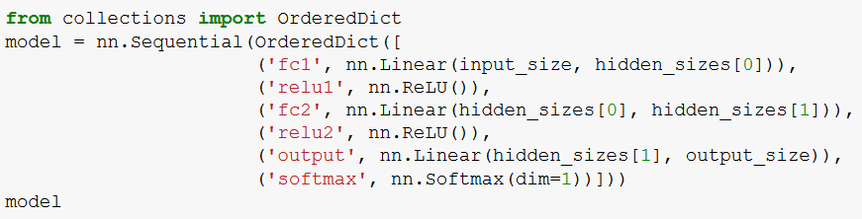

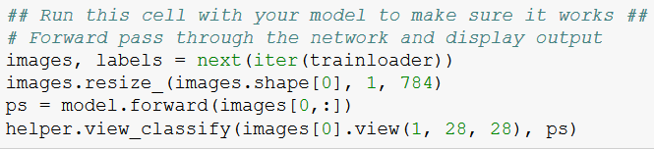

**DS nano: Unsupervised Learning**

**Lesson1_Clustering**

Clustering is one of the most popular unsupervised approaches. In a first look at clustering, you will gain an understanding of what clustering your data means. Then, you will see how the k-means algorithm works. You will put your skills to work to find groupings of similar movies!

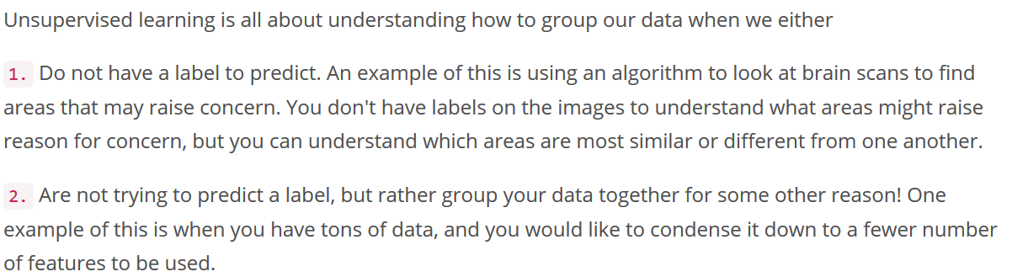

**Clustering** - groups data together based on similarities;

**Dimensionality Reduction** - condenses a large number of features into a (usually much) smaller set of features.

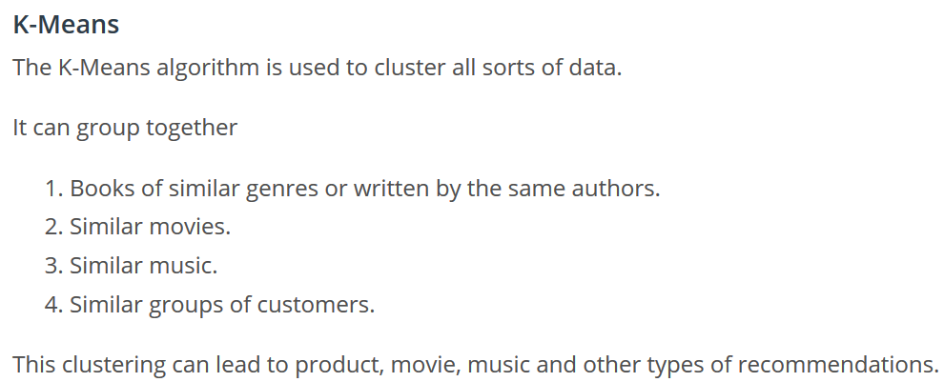

QUIZ 1.6

**Elbow Method for finding K**

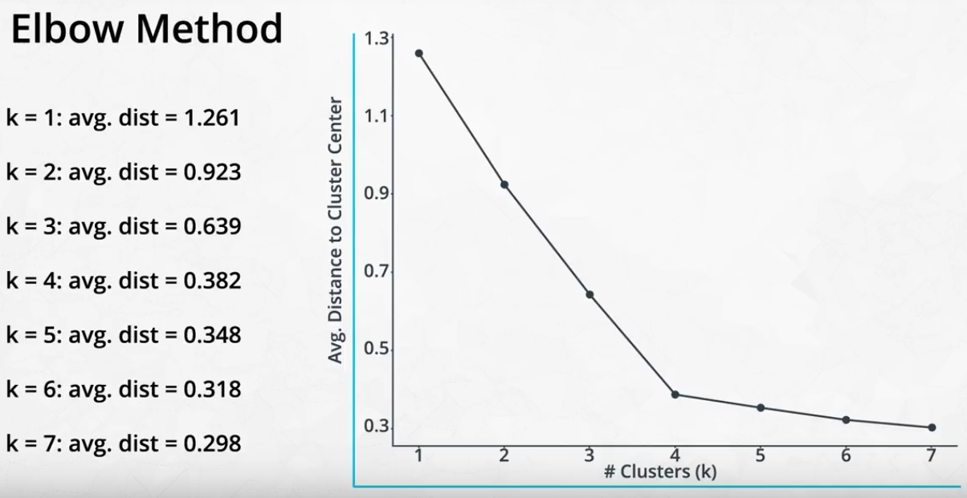

**Coding 1.10/11 solution**

**K-means Algorithms**

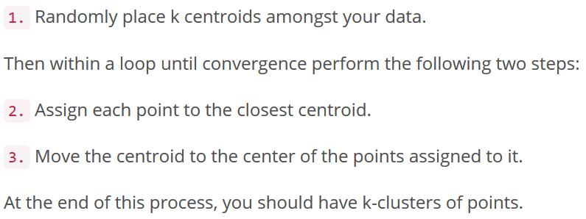

**Graphic** <https://www.naftaliharris.com/blog/visualizing-k-means-clustering/>

**Explain** <https://mubaris.com/2017/10/01/kmeans-clustering-in-python/>

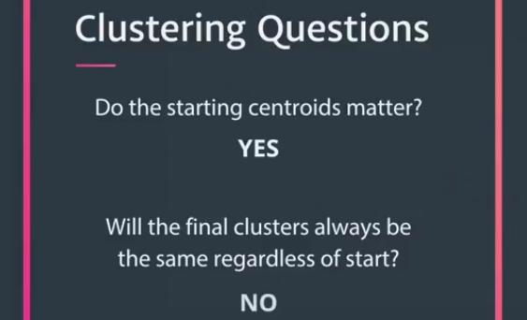

**Best grouping: avg. distance smallest**

**Scaling** 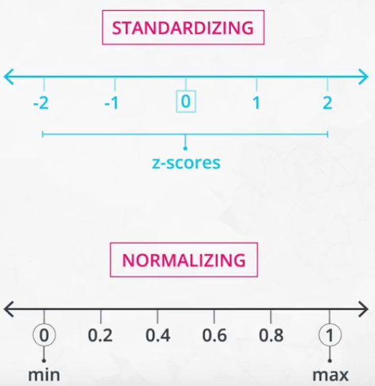

1. **Concern:** The random placement of the centroids may lead to non-optimal solutions.

**Solution:** Run the algorithm multiple times and choose the centroids that create the smallest average distance of the points to the centroids.

2. **Concern:** Depending on the scale of the features, you may end up with different groupings of your points.

**Solution:** Scale the features using Standardizing, which will create features with mean 0 and standard deviation 1 before running the k-means algorithm.

**DS nano: Unsupervised Learning**

**Lesson2_Hierarchical and Density Based Clustering**

using density based 'closeness' measures. Application: traffic classification & anomaly detection (finding points that aren't like others in your dataset).

**Hierarchical clustering eg. pizza shop model**

Paper: [Using Hierarchical Clustering of Secreted Protein Families to Classify and Rank Candidate Effectors of Rust Fungi](http://journals.plos.org/plosone/article?id=10.1371/journal.pone.0029847); Paper: [Association between composition of the human gastrointestinal microbiome and development of fatty liver with choline deficiency](https://www.ncbi.nlm.nih.gov/pubmed/21129376)

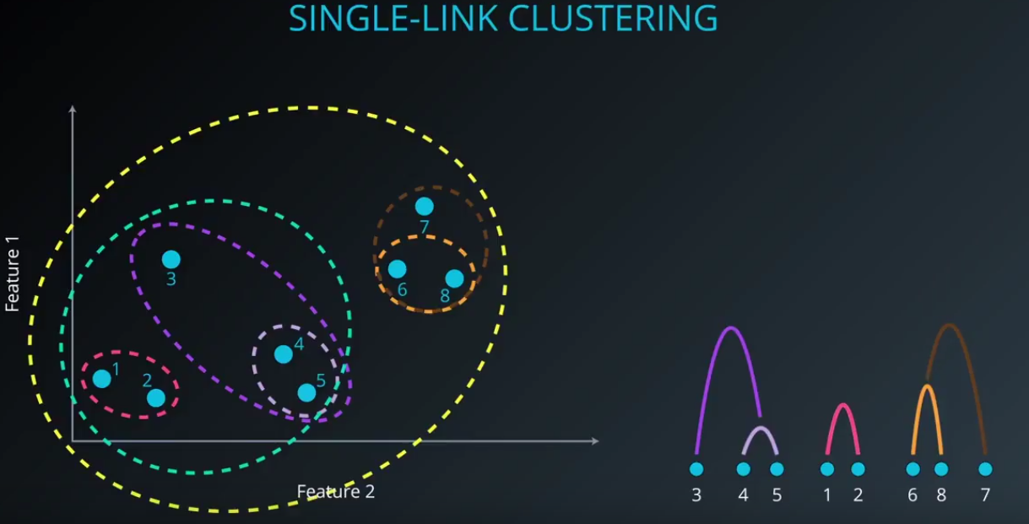

**Single-link cluster Distance: the two nearest points in two clusters; Complete-link cluster: the two farthest points; average-link cluster.**

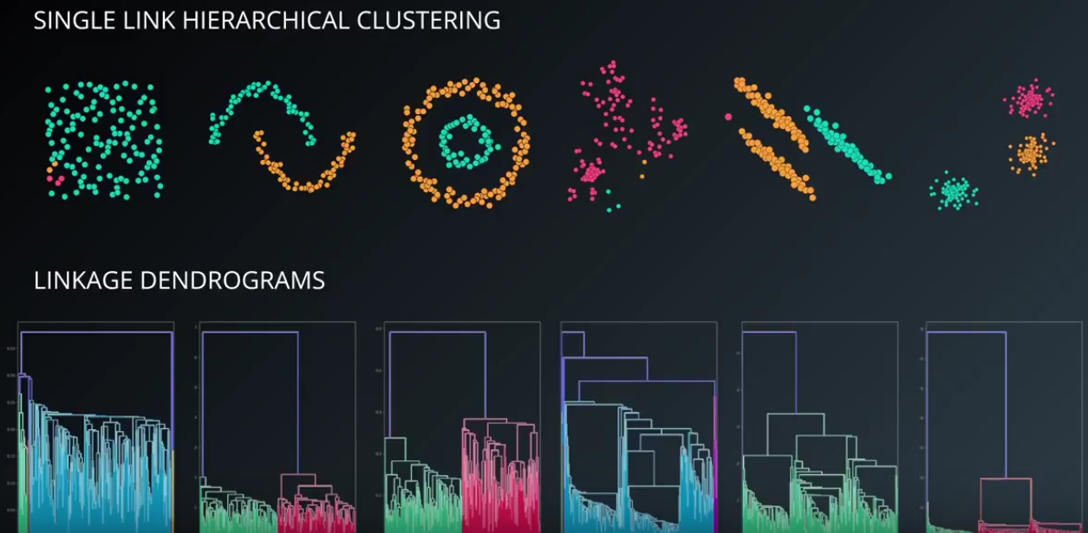

**Ward’s method (default): min variance when merging two clusters**

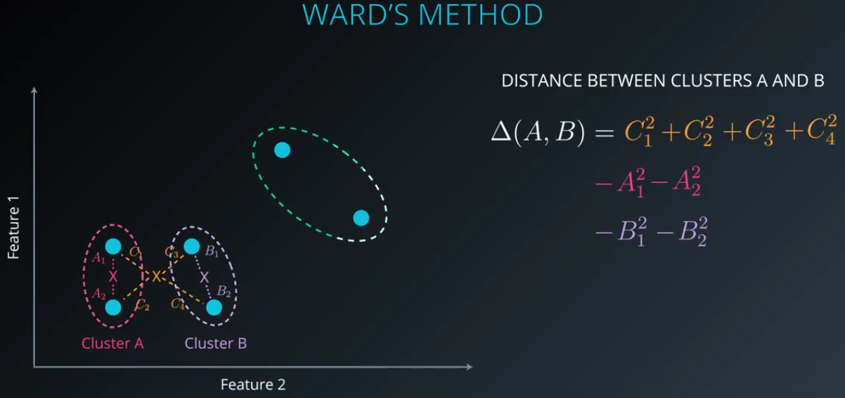

**Code**

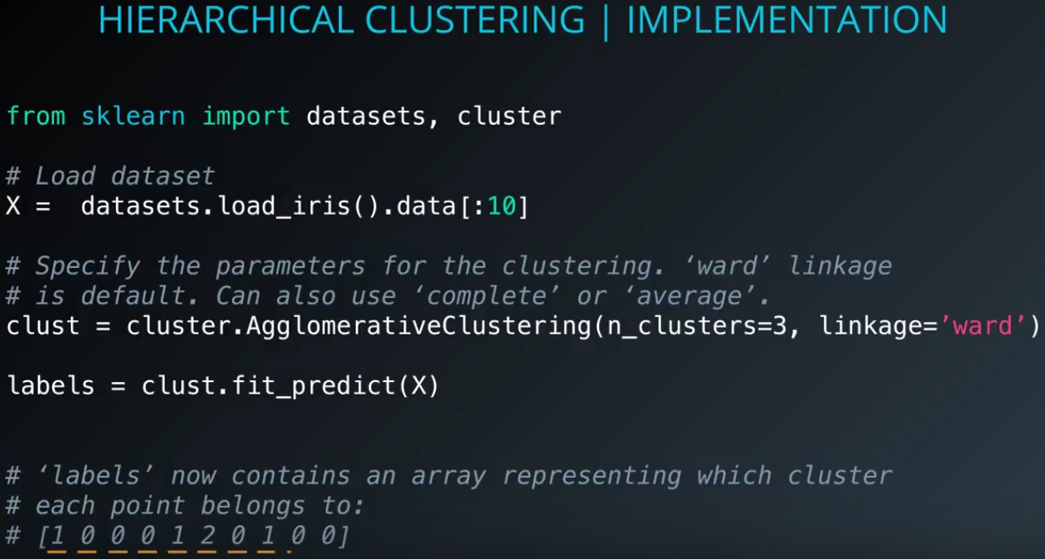

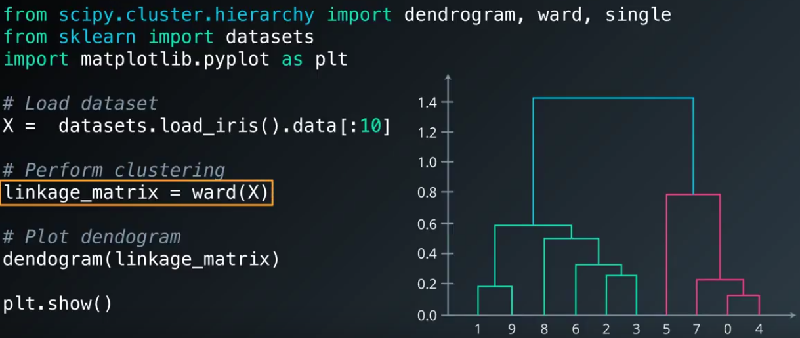

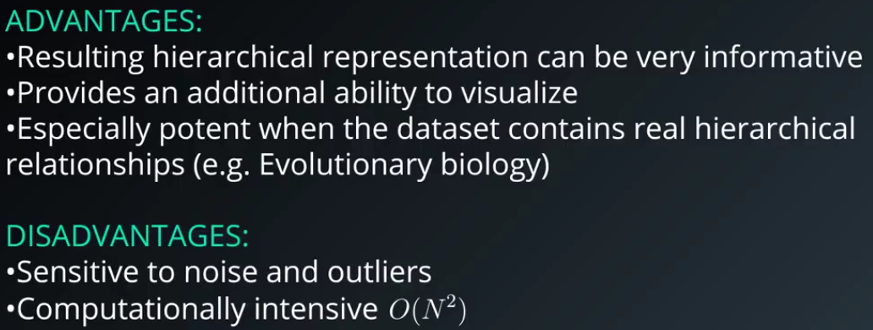

**Density-Based Clustering (DBSCAN)**

Paper: [Traffic Classification Using Clustering Algorithms](https://pages.cpsc.ucalgary.ca/~mahanti/papers/clustering.pdf)

Paper: [Anomaly detection in temperature data using dbscan algorithm](https://ieeexplore.ieee.org/abstract/document/5946052/)

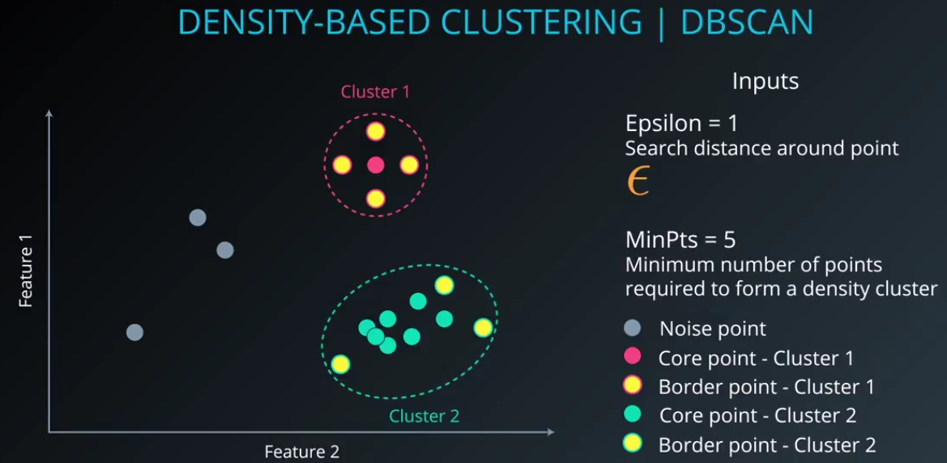

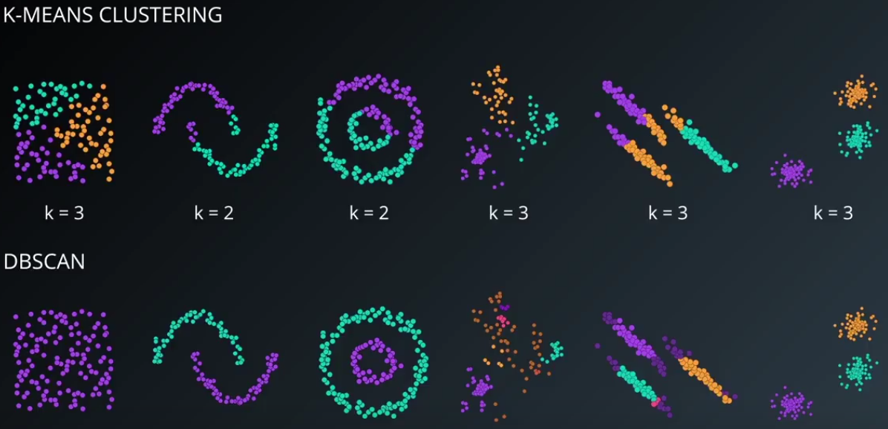

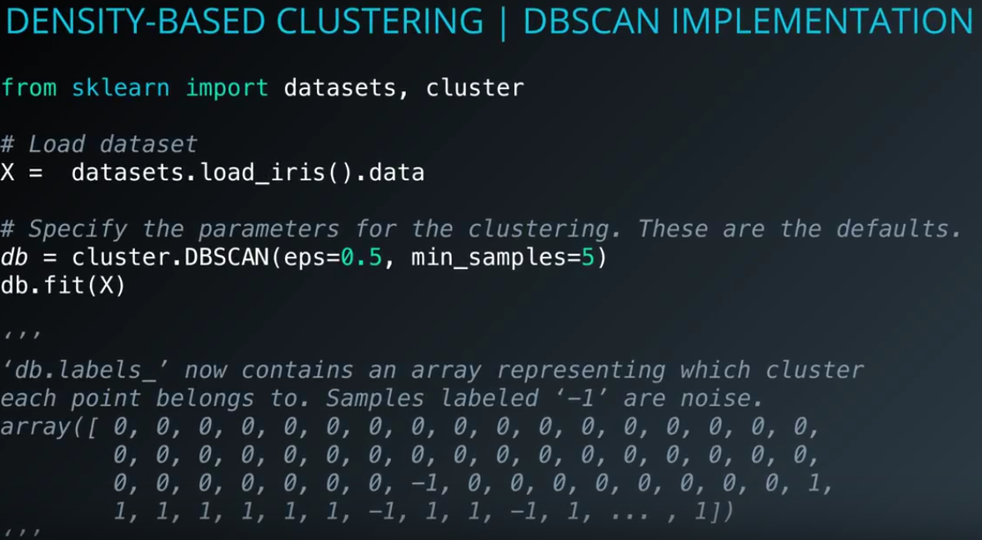

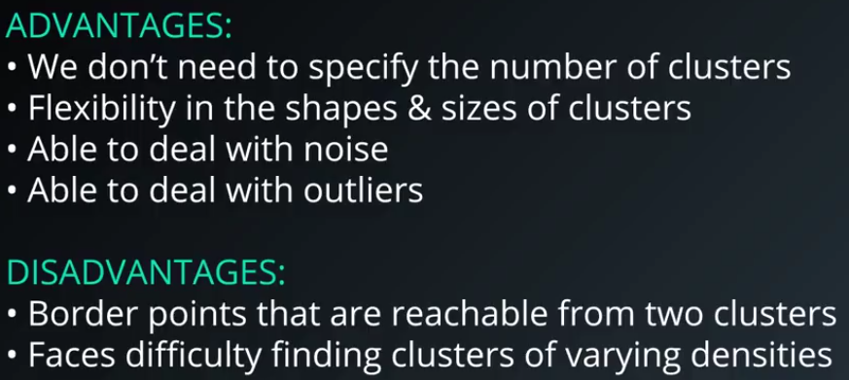

**Need to: define the distance (epsilon) & Min samples**

**DS nano: Unsupervised Learning**

**Lesson3_Gaussian Mixture Models and Cluster Validation**

To extend the density based approaches, you will get some practice with gaussian mixture models. This technique is not far from what you learned in the previous lesson, and it is the last of the clustering algorithms you will learn before moving to matrix decomposition methods.

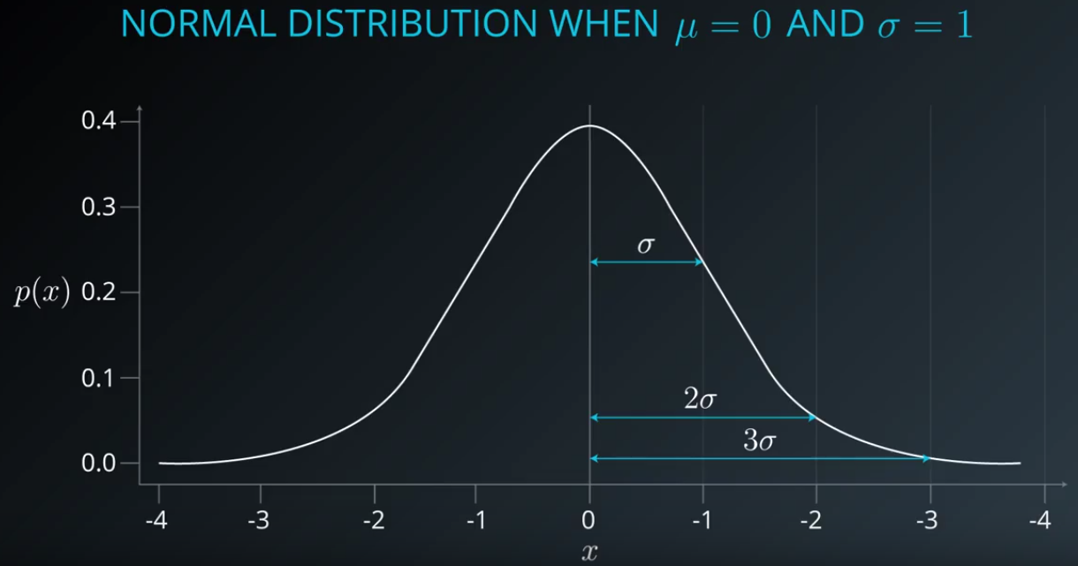

**+-1 sd: 68% data; +-2 sd: 95% data; +-3 sd: 99% data**

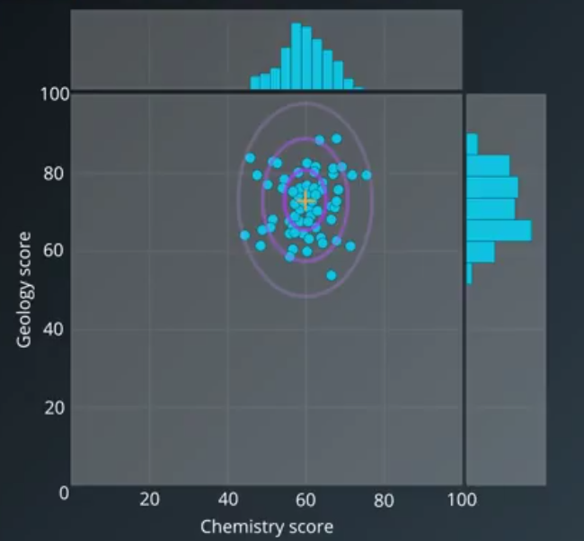

**Expectation-Maximization for Gaussian Mixtures:**

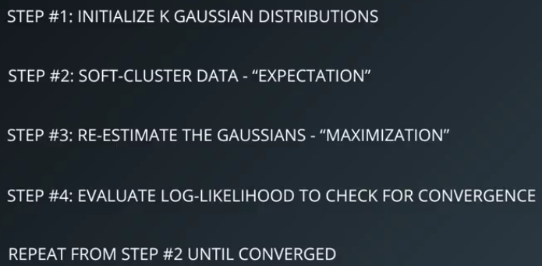

**Step 2: Calculation**

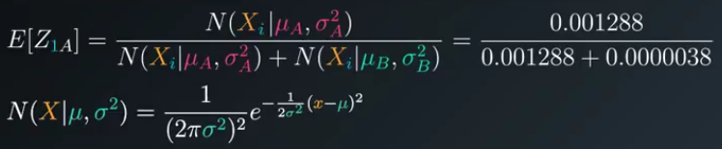

**Step 3: get the new point center**

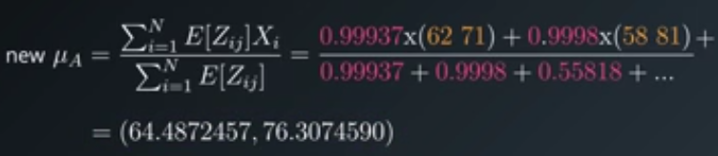

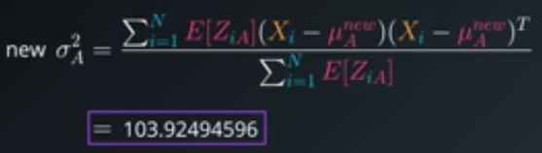

**Step 4**

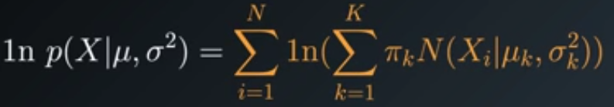

**Coding:**

**from sklearn import mixture**

**gmm=mixture.GaussianMixture(n_components=3)**

**gmm.fix(data)**

**clustering=gmm.predict(data)**

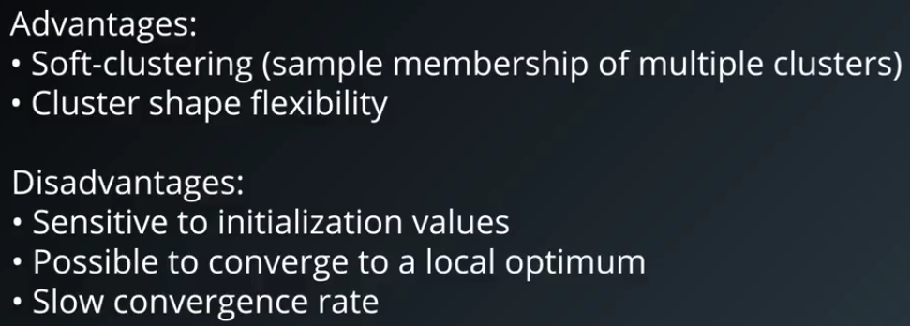

**Application:**

**Identify object moving in the pictures, or identify background by subtract moving objects.**

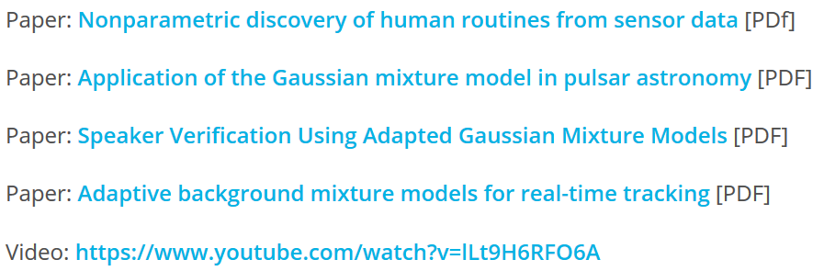

<http://citeseerx.ist.psu.edu/viewdoc/download?doi=10.1.1.681.3152&rep=rep1&type=pdf>

<https://arxiv.org/abs/1205.6221>

<http://citeseerx.ist.psu.edu/viewdoc/download?doi=10.1.1.117.338&rep=rep1&type=pdf>

<http://www.ai.mit.edu/projects/vsam/Publications/stauffer_cvpr98_track.pdf>

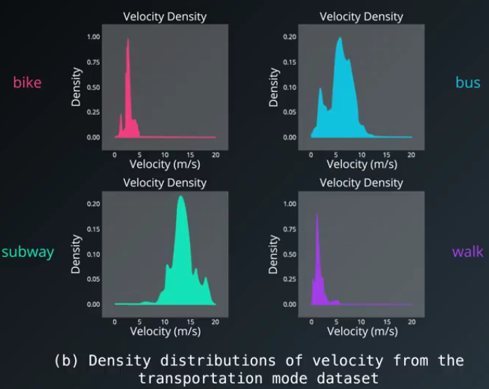

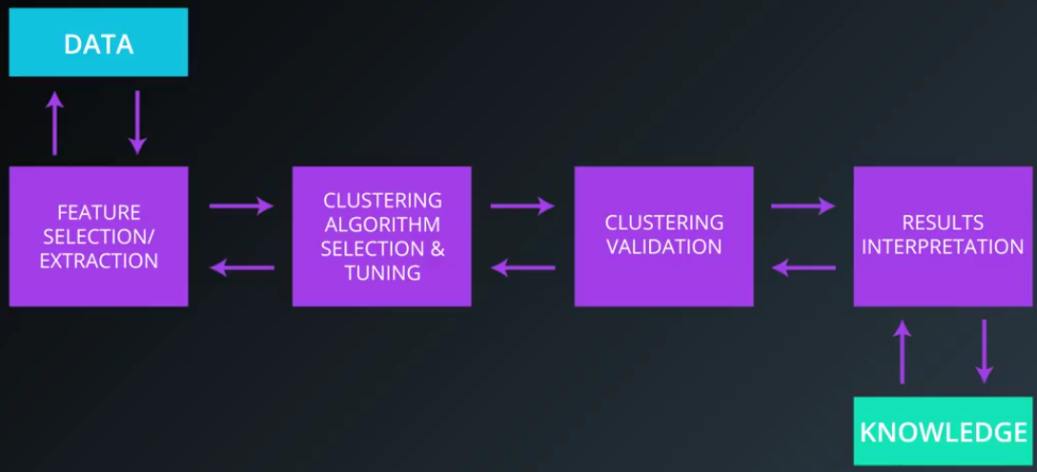

**Cluster Validation: External Validation Indices**

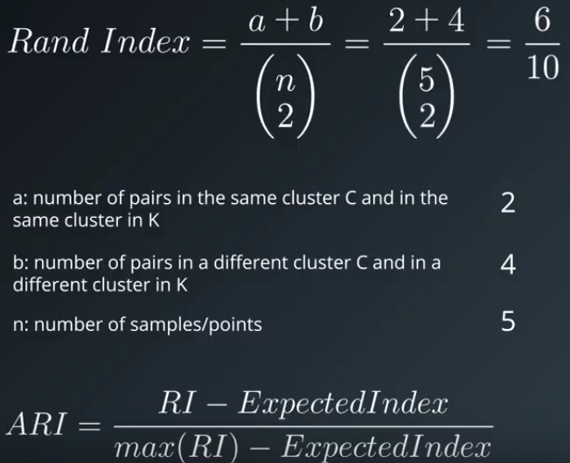

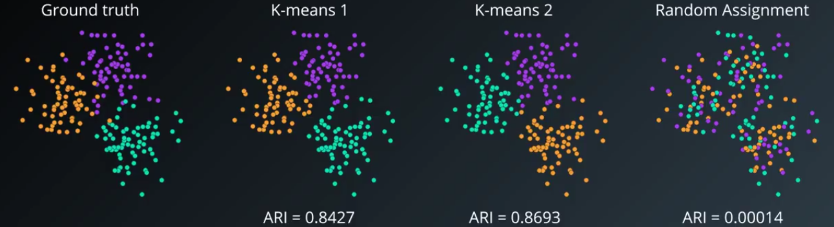

Ref: <http://faculty.washington.edu/kayee/pca/supp.pdf>

**Cluster Validation: Internal Validation Indices (unsupervised learning)**

**Silhouette coefficient**

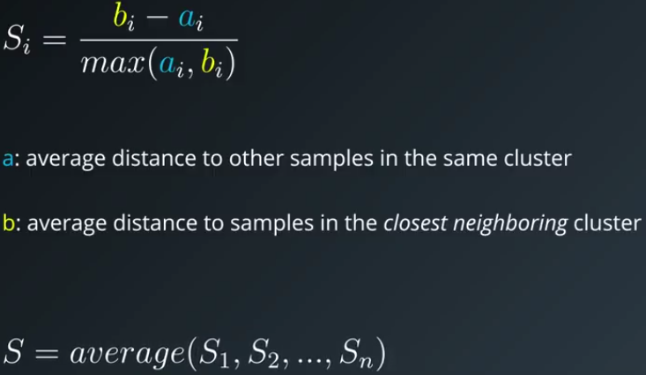

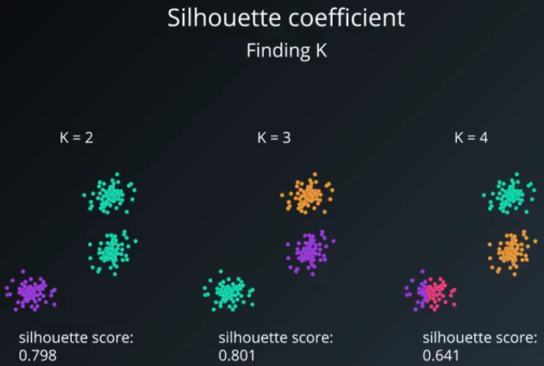

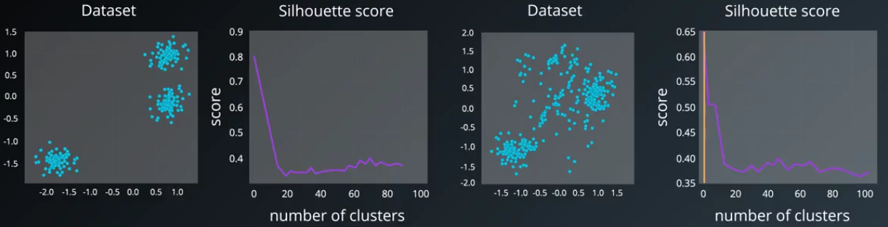

**Advantage to compare different methods:**

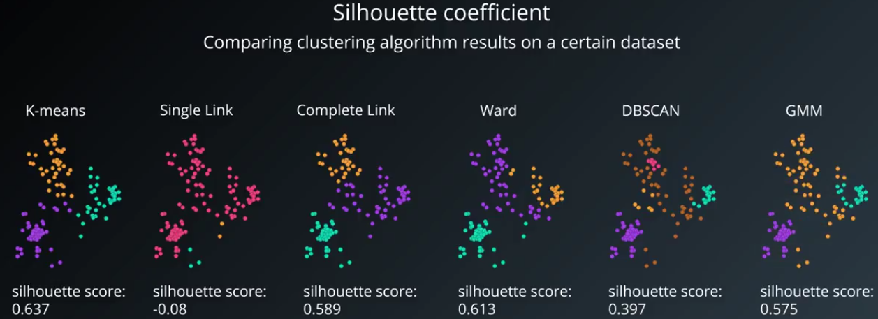

**The downsides:**

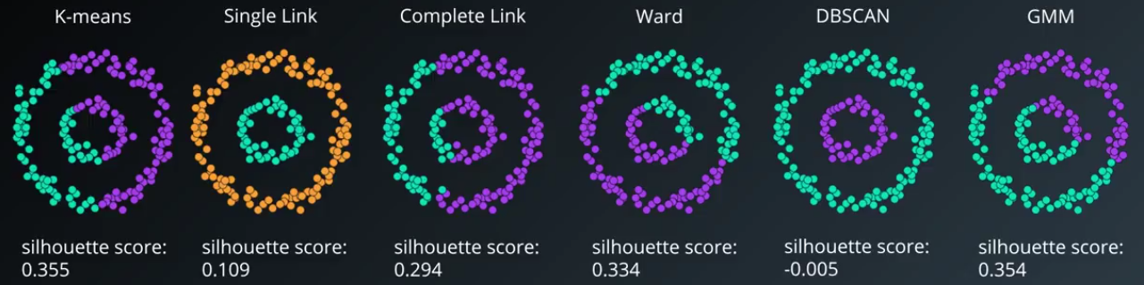

**Another Methods to fix above shortness**

**Ref: Density-Based Clustering Validation** (DBCV) – much better for methods like DBSCAN

<http://citeseerx.ist.psu.edu/viewdoc/download;jsessionid=83C3BD5E078B1444CB26E243975507E1?doi=10.1.1.707.9034&rep=rep1&type=pdf>

**DS nano: Unsupervised Learning**

**Lesson4_PCA**

Principal component analysis is one of the most popular decomposition methods available today. In this lesson, you will learn how matrix decomposition methods work conceptually. Then you will apply principal component analysis to hand written digits to reduce the dimensionality of these images.

**Principal components** are linear combinations of the original features in a dataset that retain the aim to retain the most information in the original data.

**PCA explanation:**

[**https://stats.stackexchange.com/questions/2691/making-sense-of-principal-component-analysis-eigenvectors-eigenvalues**](https://stats.stackexchange.com/questions/2691/making-sense-of-principal-component-analysis-eigenvectors-eigenvalues)

**Property:**

1. **Each component captures the largest amount of variance left in the data**

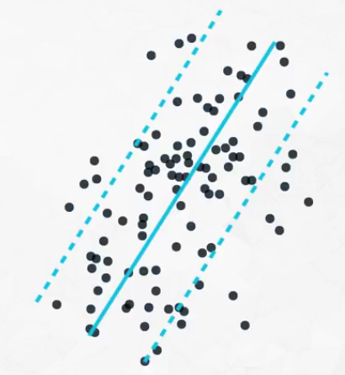 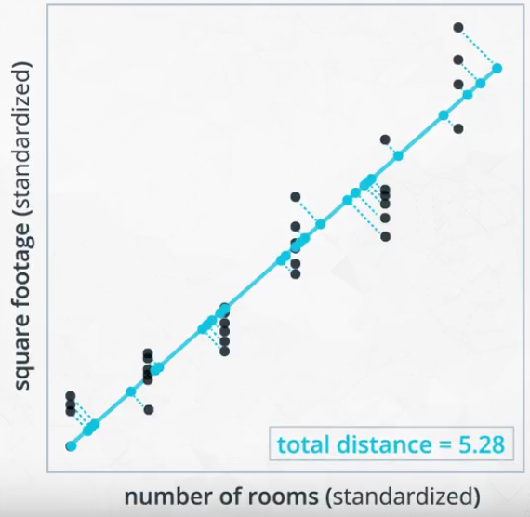

**Amount of information loss by distance**

finding a line that reduced the distances of the points to the component across all the points (same as in regression).

1. **Components are orthogonal to one another**

when there are many components, the additional components will all be orthogonal to one another. Depending on how the components are used, there are benefits to having orthogonal components. In regression, we often would like independent features, so using the components in regression now guarantees this.

<https://stats.stackexchange.com/questions/110508/questions-on-pca-when-are-pcs-independent-why-is-pca-sensitive-to-scaling-why>

**DS nano: Unsupervised Learning**

**Lesson5_Random Projection and ICA**

Another way to decompose data is through independent component analysis. In this lesson, you will see how this method can pull apart audio related to a piano, cello, and television that has been overlaid in the same file.

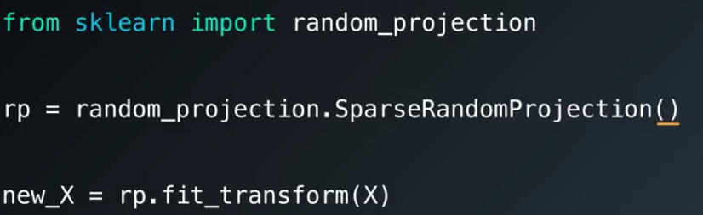

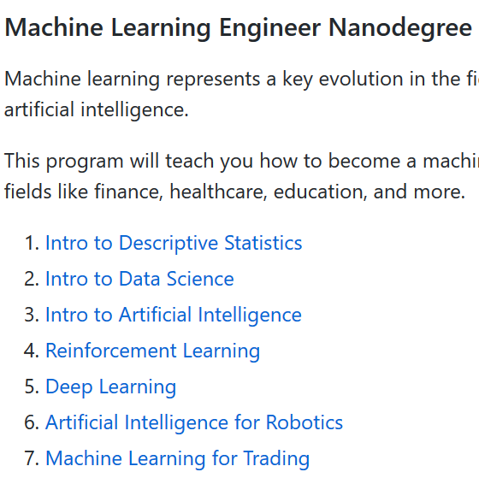

**Deep learning**

Lesson 1 from ML to DL

**Softmax**

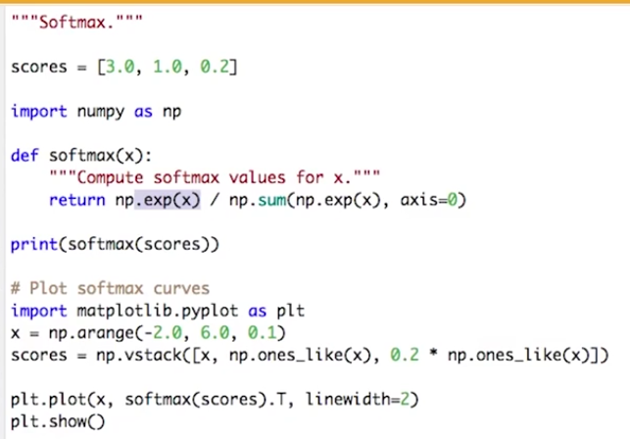

Multinomial Logistic Classification

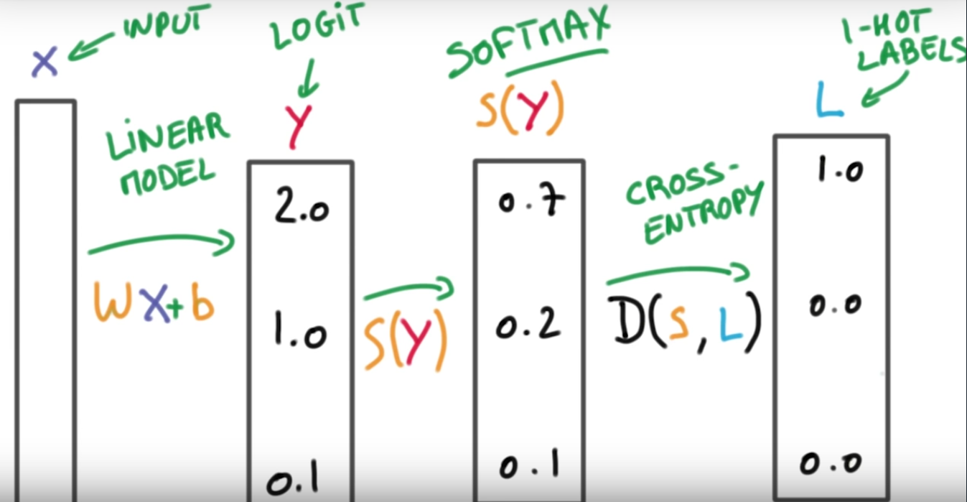

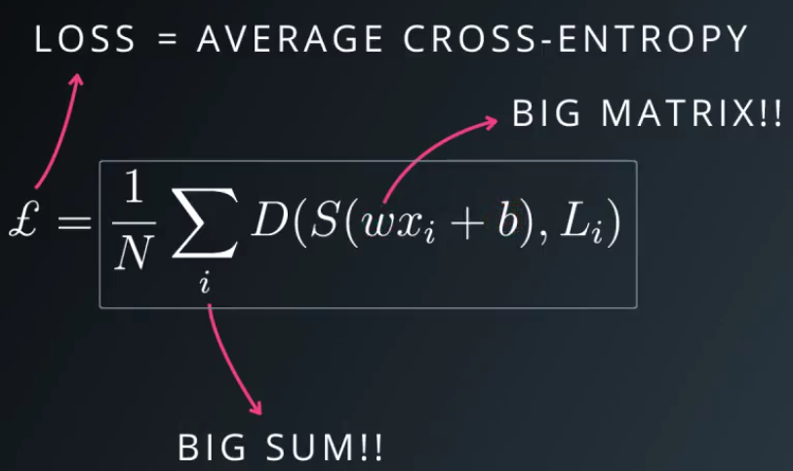

w: weights; b: bias

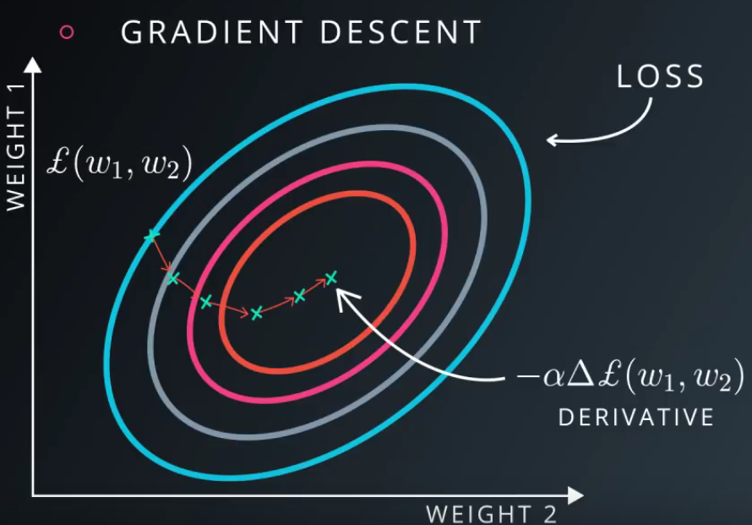

Loss function

